
NAME | REGNO.
SSEKITTO BOB SAMUEL | 23/2/306/D/149
KILABIRA KEITH | 23/2/306/D/387

COURSE UNIT: SOFTWARE ENGINEERING
COURSE: BCS
YEAR: III
SEMESTER: II
Software Processes in Software Engineering
1. Introduction
A software process is a structured set of activities required to develop a software system. It acts as a blueprint that guides developers, project managers, and stakeholders through all stages of software development including planning, designing, building, testing, deploying, and maintaining the system.
A well-defined software process ensures consistency, improves product quality, reduces risks, and helps teams deliver projects within time and budget constraints. Without a clear process, software development can become disorganized, leading to poor-quality products, missed deadlines, and increased costs.
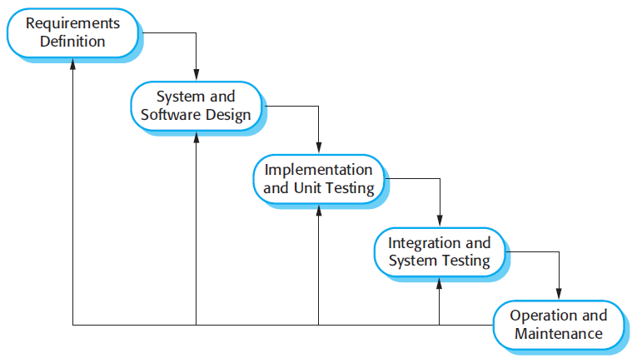

2. Key Components of Software Processes
2.1 Specification (Requirements Engineering)
This phase involves understanding and documenting what the system should do. It is one of the most critical stages because errors here can affect the entire project.
It includes:
Requirements gathering: Collecting information from stakeholders through interviews, questionnaires, and observations.
Requirements analysis: Examining the gathered requirements to ensure they are clear, complete, and feasible.
Requirements validation: Confirming that the documented requirements accurately reflect user needs.
Proper specification helps avoid misunderstandings and ensures that developers build the right system.
2.2 Design
The design phase focuses on how the system will be built. It transforms requirements into a blueprint for implementation.
Key aspects include:
System architecture design: Defining the overall structure of the system and how components interact.
Database design: Planning how data will be stored, organized, and accessed.
User interface design: Creating layouts and interactions that enhance user experience.
A good design ensures scalability, modularity, and maintainability, making the system easier to update and expand in the future.
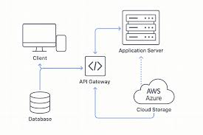
System architecture design

2.3 Implementation
Implementation is the stage where developers write the actual code based on the design specifications.
Important considerations include:
Writing clean, readable, and maintainable code.
Following coding standards and best practices.
Using appropriate programming languages and tools.
This phase also involves version control systems (e.g., Git) to manage code changes and collaboration among developers.
2.4 Testing
Testing ensures that the software works correctly and meets the specified requirements. It helps identify and fix defects before deployment.
Types of testing include:
Unit testing: Testing individual components or functions.
Integration testing: Ensuring different modules work together.
System testing: Testing the complete system as a whole.
Acceptance testing: Validating the system with end users.
Effective testing improves software quality, reliability, and user satisfaction.
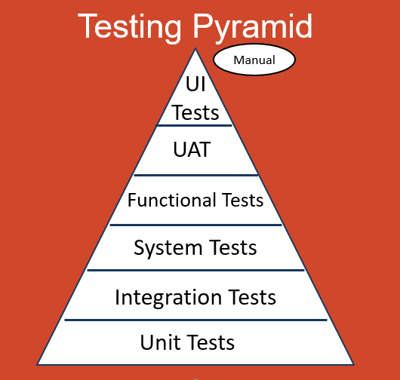

2.5 Deployment
Deployment involves releasing the software to the production environment where users can access it.
This phase includes:
Configuring servers and environments.
Installing the software.
Monitoring the system after release.
A smooth deployment ensures minimal disruption to users and reduces the chances of system failure.
2.6 Maintenance
Maintenance occurs after deployment and involves ongoing support and improvement of the software.
It includes:
Fixing bugs and errors.
Improving performance and efficiency.
Adding new features based on user feedback.
Maintenance is essential because software must evolve to meet changing user needs and technological advancements.
3. Software Process Models
Waterfall Model
The Waterfall Model is a linear and sequential approach where each phase must be completed before moving to the next.
Characteristics:
- Simple and easy to understand.
- Clearly defined stages.
- Limited flexibility once development begins.
It is best suited for projects with well-defined and stable requirements.

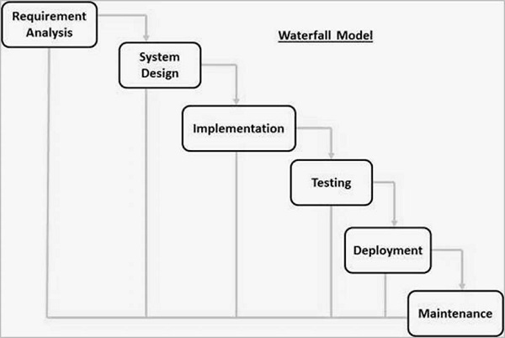
V-Model
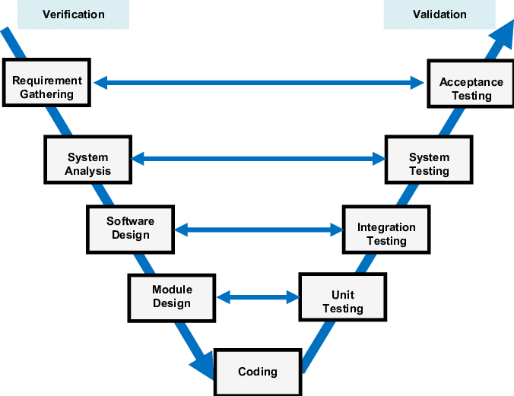
The V-Model (Verification and Validation Model) is an extension of the Waterfall Model that emphasizes testing at each development stage.
Key features:
- Each development phase has a corresponding testing phase.
- Early detection of defects.
- Strong focus on quality assurance.
It is useful for projects where reliability is critical.

Incremental Model
In the Incremental Model, the system is developed in smaller parts called increments. Each increment adds new functionality.
Advantages:
- Early delivery of partial working software.
- Easier testing and debugging.
- Flexibility to incorporate changes.
This model is suitable for projects with evolving requirements.
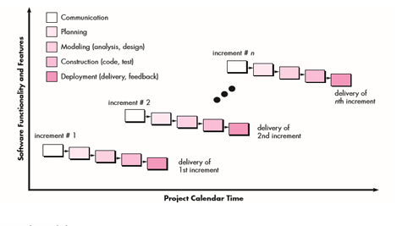
Spiral Model
The Spiral Model combines iterative development with risk analysis. Development is carried out in cycles called spirals.
Key aspects:
- Continuous risk assessment.
- Iterative refinement of the system.
- Strong focus on planning and evaluation.
It is ideal for large and complex projects with high risk.
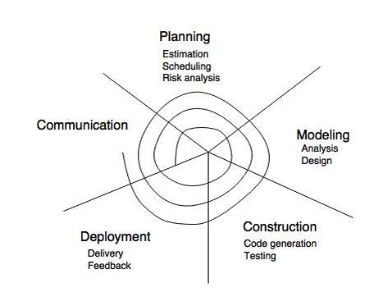
Agile Model
The Agile Model is an iterative and flexible approach that focuses on collaboration, customer feedback, and rapid delivery.
Key principles:
- Continuous delivery of small increments.
- Close collaboration with stakeholders.
- Ability to adapt to changing requirements.
Agile is widely used in modern software development due to its flexibility and efficiency.
4. Key Principles
Modern software processes are guided by several important principles:
Iterative development: Building software in small cycles to allow continuous improvement.
Collaboration: Encouraging teamwork among developers, stakeholders, and users.
Flexibility: Adapting to changes in requirements and technology.
Automation: Using tools to automate testing, integration, and deployment.
These principles help improve productivity, reduce errors, and deliver better software products.
5. Software Process Metrics
Metrics are used to measure the effectiveness and efficiency of software processes.
Common metrics include:
Productivity: Amount of work completed in a given time.
Quality: Number of defects or errors in the software.
Time-to-market: How quickly the software is delivered.
Maintainability: Ease of updating and modifying the system.
Using metrics helps teams identify areas for improvement and make better decisions.
6. Emerging Trends
Software engineering continues to evolve with new trends shaping development processes:
DevOps: Integrating development and operations to improve collaboration and speed.
AI-assisted development: Using artificial intelligence to automate coding and testing tasks.
Microservices architecture: Building applications as a collection of small, independent services.
Continuous feedback: Collecting user feedback regularly to improve the system.
These trends help organizations stay competitive and deliver high-quality software faster.
7. Conclusion
Software processes play a vital role in ensuring the successful development of software systems. They provide structure, improve efficiency, and enhance product quality. Selecting the appropriate process model depends on factors such as project size, complexity, team experience, and risk level.
By following well-defined processes and embracing modern practices, organizations can deliver reliable, scalable, and user-friendly software solutions.

